Exercise 1.

The data table below represents the number of quarters contributed for retirement per 1,000 French people aged 65

Number of contribution quarters | Number of participants
< 80 | 92
[80 ; 100 [ | 110
[100 ; 150 [ | 239
[150 ; 235 [ | 382
≥ 235 | 177
Total | 1 000

Thus, one can deduce that:
- The variable studied is continuous qualitative
- True
- False
- The appropriate graphical tool to represent the data of the variable studied, is the bar chart.
- True
- False
- More than 20% of the retirees studied contributed less than 100 quarters.
- True
- False
- Graphically, the best represented modality is [80; 100 [
- True
- False
- The cumulative frequency curve associated with the data is a staircase function.
- True
- False

Exercise 2.
A sales manager of a company wants to study the weekly grocery expenses of Parisian households.
The figure below shows the boxplot associated with the observed data of the variable studied.
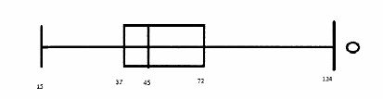

Thus, one can deduce that:
- Data has no outliers
- True
- False
- 0 is the minimum value of the data
- True
- False
- 124 is the maximum value of the data
- True
- False
- 25% of Parisian households studied have a weekly expense in groceries of more than 72 euros.
- True
- False
- 50% of the Parisian households studied have a weekly expense in groceries of less than 45 euros.
- True
- False

Exercise 3.
The HR manager of a large company is interested in the daily number of absent employees.
The figure below shows the curve of increasing cumulative frequencies associated with the data of the variable studied.
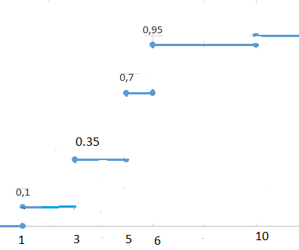
Thus, one can deduce that:
- The population studied is “the employees”
- True
- False
- The appropriate graphical tool to represent the data of the variable studied, is the bar chart.
- True
- False
- 3 is the most frequent modality
- True
- False
- The first quartile is equal to 3
- True
- False
- The third quartile is equal to 6
- True
- False

Exercise 4.
The quality manager of an online travel site is interested in the waiting time (in minutes) on the phone for a customer to be received by the site's sales department.
The figure below shows the curve of increasing cumulative frequencies.

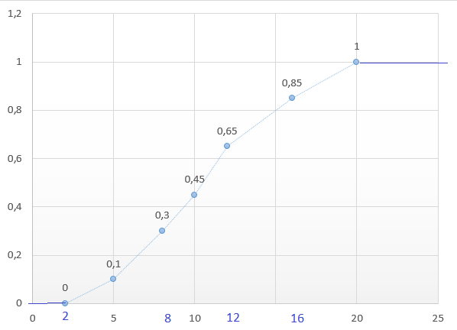

Thus, one can deduce that:
- 85% of the clients studied waited more than 16 minutes
- True
- False
- 20% of the clients studied waited between 12 and 16 minutes
- True
- False
- 55% of the clients studied waited more than 10 minutes
- True
- False
- The first quartile is equal to 8. 73 minutes.
- True
- False
- The third quartile is equal to 11. 52 minutes
- True
- False

